**Step1:**

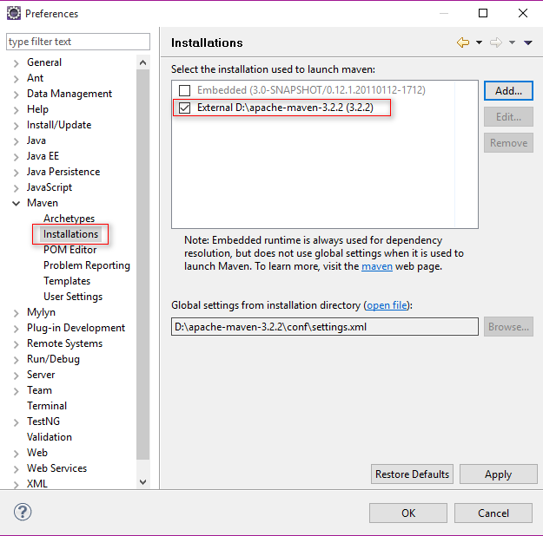

**Step2:**

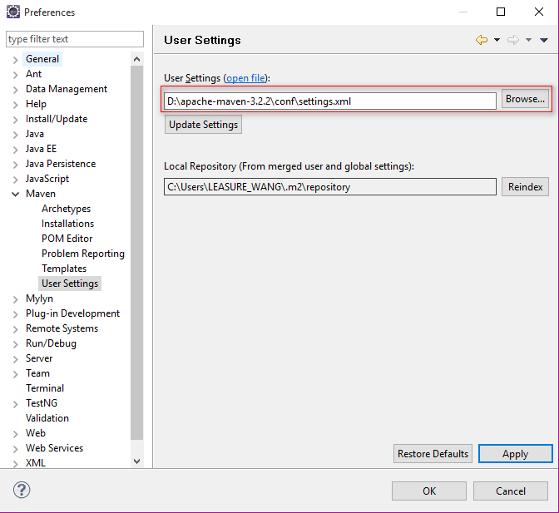

**Step3: create java project**

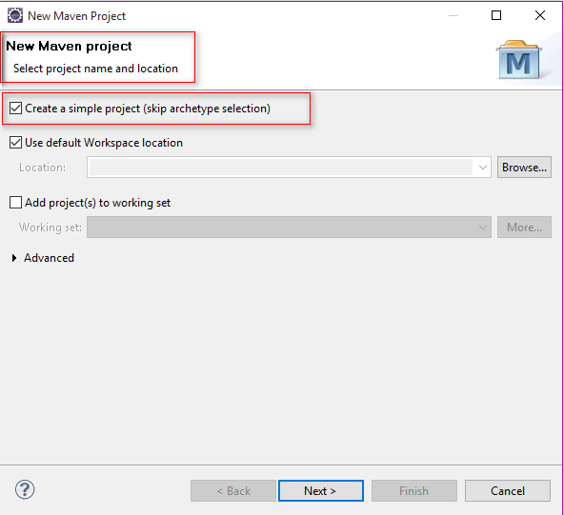

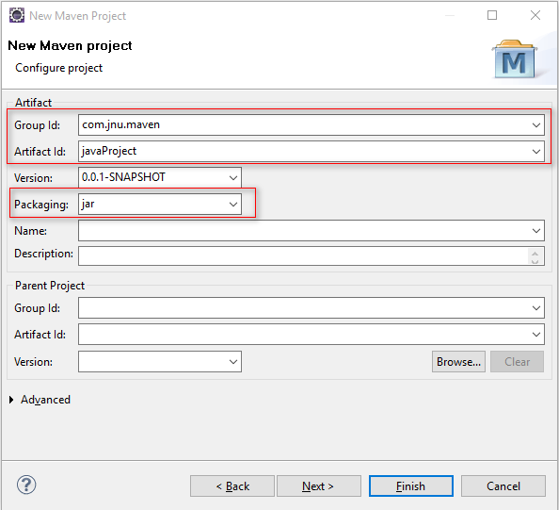

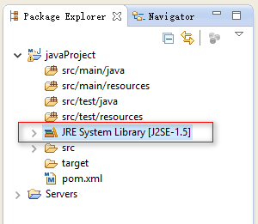

You have two methods to change the JDK If the JDK is not 1.7. First one is remove the old one and then add the latest. Second method is add below config in the **settings.xml.**

**D:\apache-maven-3.2.2\conf\settings.xml**

<profile>

<id>jdk17</id>

<activation>

<activeByDefault>true</activeByDefault>

<jdk>1.7</jdk>

</activation>

<properties>

<maven.compiler.source>1.7</maven.compiler.source>

<maven.compiler.target>1.7</maven.compiler.target>

<maven.compiler.compilerVersion>1.7</maven.compiler.compilerVersion>

</properties>

</profile>

**Step4: create web project**

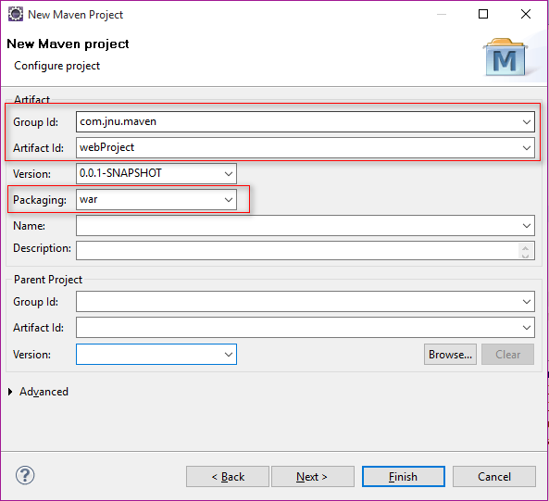

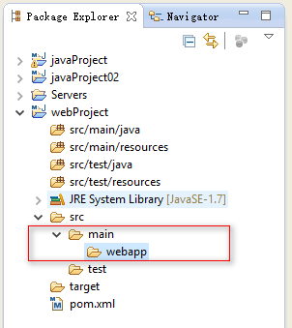

Add the WEB-INF

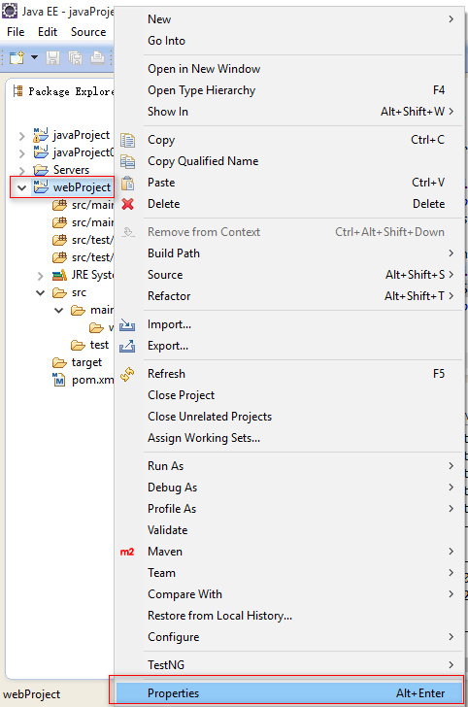

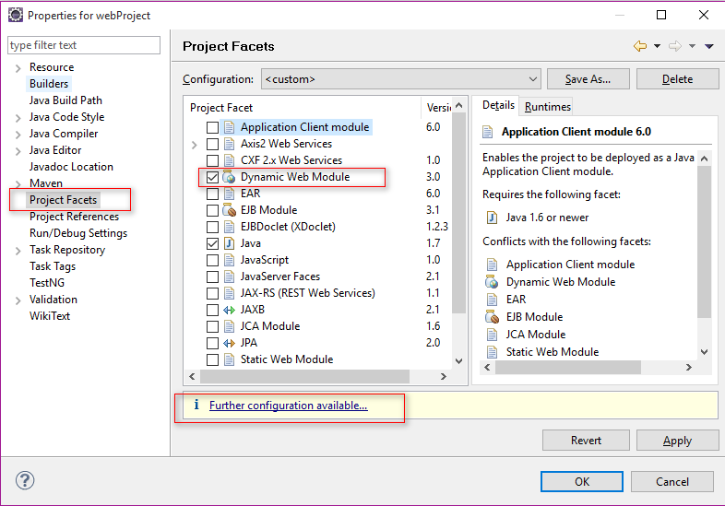

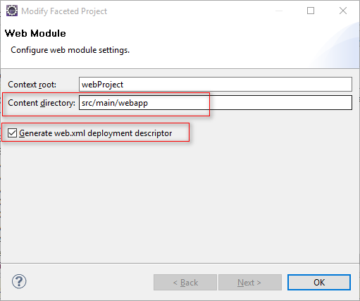

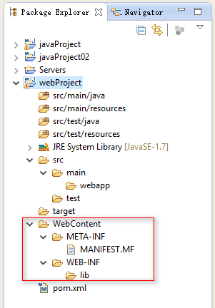 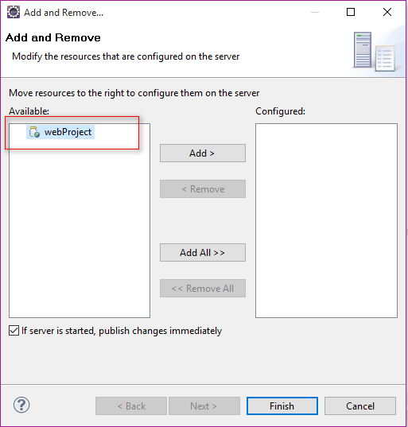

You need change the version value in the **.settings.xml** If you cannot run the web project in the tomcat. And the version number should be samller.

<installed facet="jst.web" **version="3.0"**/>

